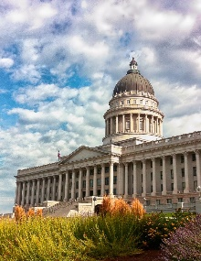
CAPITOL HILL NEIGHBORHOOD COUNCIL

CHNC Purpose Statement

Enhance and strengthen the vitality of our neighborhoods by fostering a participatory community of Informed, Engaged and Empowered residents working together to improve our neighborhoods.

www.chnc-slc.org
October 31, 2018
To the Members of the Historic Landmarks Commission
Re: PLNHLC2018-00616

To the Commission:
The above- referenced project has been reviewed by the Infrastructure and Planning Committee of the Capitol Hill Neighborhood Council. We support the project’s purpose and overall design, particularly in preserving and restoring the exterior and interior of the Union Pacific Railroad Station. The scale of the proposed hotel building is appropriate for the surrounding area. It is planned and sited so as to integrate with its surroundings and contribute to the existing plaza at The Gateway in a positive manner.
We would, however, like to see the design of the west façade modified to reduce its monolithic appearance. This could be accomplished by introducing a substantial area of another material such as red brick, which is prominent in the historic railroad station. The traditional division of the building into base, body and top could be accomplished in this way, making it more reflective of the historic station and, we believe, simply a better design.
Finally, we would like to express our appreciation to The Athens Group for taking the initiative in seeking our Council’s input on their project.

Sincerely,
David R. Scheer, Chair
Infrastructure and Planning Committee
Capitol Hill Neighborhood COuncil

